

WIDE BAY GOODCHILD SHIELD

50/50 MATCHES

RULES and COMPETITION PROCEDURES

# THE PREAMBLE – THE SPIRIT OF CRICKET

*Cricket is a game that owes much of its unique appeal to the fact that it should be played not only within its Laws but also within the Spirit of the Game. Any action which is seen to abuse this spirit causes injury to the game itself. The major responsibility for ensuring the spirit of fair play rests with the captains.*

**1** There are two Laws which place the responsibility for the team’s conduct firmly on the captain.

## Responsibility of captains

The captains are responsible at all times for ensuring that play is conducted within the Spirit of the Game as well as within the Laws.

## Player’s conduct

In the event of a player failing to comply with instructions by an umpire, or criticising by word or action the decisions of an umpire, or showing dissent, or generally behaving in a manner which might bring the game into disrepute, the umpire concerned shall in the first-place report the matter to the other umpire and to the player’s captain, and instruct the latter to take action.

## 2 Fair and unfair play

According to the Laws the umpires are the sole judges of fair and unfair play. The umpires may intervene at any time and it is the responsibility of the captain to take action where required.

**3 The umpires are authorised to intervene in cases of:**

* Time wasting
* Damaging the pitch
* Dangerous or unfair bowling
* Tampering with the ball
* Any other action that they consider to be unfair

**4 The Spirit of the Game involves RESPECT for:**

* Your opponents
* Your own captain and team
* The role of the umpires
* The game’s traditional values

**5 It is against the Spirit of the Game:**

* To dispute an umpire’s decision by word, action or gesture
* To direct abusive language towards an opponent or umpire
* To indulge in cheating or any sharp practice, for instance:

1. To appeal knowing that the batsman is not out
2. To advance towards an umpire in an aggressive manner when appealing
3. To seek to distract an opponent either verbally or by harassment with persistent clapping or unnecessary noise under the guise of enthusiasm and motivation of one’s own team

**6 Violence**

There is no place for any act of violence on the field of play.

## 7 Players

Captains and umpires together, set the tone for the conduct of a cricket match. Every player is expected to make an important contribution to this.

*Extracted from the current Laws of Cricket © MCC*

**Contents**

# Playing Conditions

All matches shall be played in accordance with the current Laws of Cricket, including Experimental Laws as recognised for the time being by Cricket Australia, as amended by the Board of Queensland Cricket on advice of the Wide Bay Committee as set out in these regulations and playing conditions.

These playing conditions apply for all 50 matches matches in the following competitions. Where competitions are individually identified, such playing conditions are to apply to that competition only.

**Goodchild Shield 50 over competition**

## 1 Laws of Cricket

The Laws of Cricket shall apply except as varied below.

The brand of ball must be one manufactured by Kookaburra only. RED, 4 piece CLUB MATCH ball is the preferred option.

## 2 Duration of Matches and Composition of Team

**2.1** Matches shall be of one day’s scheduled duration.

1. 100 overs maximum per match per day’s play.

1. In the event of a team batting first being dismissed inside their 50 overs, or in less than the rescheduled number of overs in an interrupted match, the remaining whole overs will not be added to the innings of the team batting second. The team batting second shall be entitled to bat 50 overs, or the rescheduled number of overs in an interrupted match, or until dismissed.

**2.2** A team shall consist of twelve nominated players however only eleven are permitted to bat. All twelve players can bowl.

1. Each captain, deputy or team manager shall nominate his/her players in writing to one of the umpires prior to the toss. No player may be replaced after the nomination without the consent of the opposing captain.

1. Eleven fieldsmen only shall be on the field of play at any one time.

1. Unlimited interchange of fielders from the twelve players nominated to take part in the match shall be allowed. Should a player be injured / ill at any stage following the nomination of players and hence not be able to take his/her place in the field, the replacement fielder must in the first instance be one of the twelve nominated players. A substitute fielder will thereafter be allowed.

## 3 Hours of Play and Intervals

**3.1 Hours of Play**

There will be two sessions of 3½ hours each, separated by a break as per clauses 3.1.1.

**3.1.1**

09.00am -12.30pm *Session 1*

12.30pm – 1.10pm *Interval*

1.10pm – 4.40pm *Session 2*

**3.1.3 Venues** - If it is necessary for Wide Bay Cricket to transfer a match, the hours of play applying to the new venue shall be determined by Wide Bay Cricket.

**3.2 Interval between Innings**

The innings of the team batting second shall not commence before the time for the scheduled interval between innings unless the team batting first has completed its innings at least 40 minutes prior to the scheduled interval, in which case a ten-minute interval will occur and the team batting second will commence its innings and the interval will occur as scheduled.

1. Except as provided in clauses 3.2 (b) and 3.2 (c), the interval shall be of 40 minutes’ duration.

1. Where up to 60 minutes of actual playing time has been lost, the interval will be reduced to 30 minutes.

1. Where more than 60 minutes of actual playing time has been lost, the interval will be reduced to 20 minutes.

Notwithstanding clauses 5.1 (b) and 5.2.2 (b) the interval shall in all cases be a minimum of 20 minutes.

* 1. **Intervals for Drinks**

Two drinks breaks per session shall be permitted, overs 17 & 34. The provisions of Law 15.9 shall be strictly observed except that under conditions of extreme heat the umpires will permit extra intervals for drinks. An individual player may be given a drink either on the boundary edge or at the fall of a wicket, on the field, provided that no playing time is wasted. No other drinks shall be taken onto the field without the permission of the umpires. Any player taking drinks onto the field shall be dressed in approved clothing and equipment.

* 1. **Extra Time**

Provision has been made for up to 50 minutes of extra official playing time for Day 1 (Saturday), in addition to extra playing time made available as provided in clauses 3.2 (b) and 3.2 (c).

No extra playing time shall be made available except as provided in clauses 3.2 (b) and 3.2 (c) for Day 2 (Sunday).

## 4 Appointment of Umpires

The Wide Bay Cricket UMPIRES Association shall appoint umpires for the match. The umpires should be members of the Wide Bay Umpires Association where available. If umpires from this panel are not available, then suitably qualified umpires deemed to be of acceptable standard shall be appointed by the host Association.

## 5 Length of Innings

Penalties for the fielding team shall apply for not bowling the required overs by the scheduled or rescheduled time for the cessation of each session (**see clause 13**).

**5.1 Uninterrupted Matches**

1. Each team shall bat for 50 overs unless all out earlier. A team shall not be permitted to declare its innings closed.

1. If the team fielding first fails to bowl the required number of overs by the scheduled time for cessation of the first session, play shall continue until the required number of overs has been bowled.

1. If the team batting first is dismissed in less than 50 overs, the team batting second shall be entitled to bat for 50 overs.

1. If the team fielding second fails to bowl 50 overs by the scheduled cessation time, the hours of play shall be extended until the required number of overs has been bowled or a result achieved.

**5.2 Delayed or Interrupted Matches**

**5.2.1 General**

1. The object shall always be to rearrange the number of overs so that both teams have the opportunity of batting for the same number of overs. A team shall not be permitted to declare its innings closed. A minimum 15 overs have to be bowled to the team batting second to constitute a match. The calculation of the number of overs to be bowled shall be based on an average rate of 14.28 overs per hour in the total time available for play. If a reduction of the number of overs is required, any recalculation must not cause the match to be rescheduled to finish earlier than the original cessation time. This time may be extended to allow for one extra over for both teams to be added if required.

1. If the team fielding second fails to bowl the required number of overs by the scheduled cessation time, the hours of play shall be extended until the overs have been bowled or a result achieved.

1. The team batting second shall not bat for a greater number of overs than the first team unless the latter has been all out in less than the agreed number of overs.

1. Any uncompleted over included in the overs already bowled shall be regarded as a complete over.

1. Fractions are to be ignored in all calculations regarding the number of overs to be bowled.

**5.2.2 Delay or Interruption to the Innings of the Team Batting First**

1. If the number of overs of the team batting first is reduced, a fixed time will be specified for the completion of the first session, as calculated by applying the provisions of clauses 3.2 and 5.2.1 (a).

1. If the team fielding first fails to bowl the required number of overs by the scheduled time for cessation of the first session, play shall continue until the required number of overs has been bowled.

**Refer to** **Appendix 5**

**5.2.3 Delay or Interruption to the Innings of the Team Batting Second**

If there is a suspension in play during the second innings, the overs shall be reduced at a rate of 14.28 overs per hour for time lost. However, should the innings of the team batting first have been completed prior to the scheduled or rescheduled time for commencement of the interval then any calculation relating to the revision of overs shall not be effective until an amount of time equivalent to that by which the second innings started early has elapsed.

**Refer to** **Appendix 6**

## 6 Restrictions on the placement of fieldsmen

**6.1** At the instant of delivery, there may not be more than 5 fieldsmen on the leg side for the entire match.

In addition to the restriction contained in playing condition (2.2 c) above, further fielding restrictions shall apply to certain overs in each innings. The nature of such fielding restrictions and the overs during which they shall apply are set out in the following paragraphs.

1. The following fielding restrictions shall apply:
   1. Two semi-circles shall be drawn on the field of play. The semicircles shall have as their centre the middle stump at either end of the pitch. The radius of each of the semi-circles shall be 30 yards (27.43 metres). The semi-circles shall be linked by two parallel straight lines drawn on the field. (Refer attached Appendix 1). The fielding restriction areas should be marked by continuous painted white lines or ‘dots’ at 5 yard (4.57 metres) intervals, each ‘dot’ to be covered by a white plastic or rubber (but not metal) disc measuring 7 inches (18 cm) in diameter.
   2. At the instant of delivery:

▪ Powerplay 1 - no more than two (2) fieldsmen shall be permitted outside this fielding restriction area. In an innings of 50 overs, these are overs 1 to 10 inclusive.

▪ Powerplay 2 - no more than four (4) fieldsmen shall be permitted outside this fielding restriction area. In an innings of 50 overs, these are overs 11 to 40 inclusive ▪ Powerplay 3 - no more than five (5) fieldsmen shall be permitted outside this fielding restriction area. In an innings

of 50 overs, these are overs 41 to 50 inclusive

1. In circumstances when the number of overs of the batting team is reduced, the number of overs within each Powerplay of the innings shall be reduced in accordance with the table below. For the sake of clarity, it should be noted that the table shall apply to both the 1st and 2nd innings of the match.

Innings

Duration Powerplay 1 Powerplay 2 Powerplay3

15 3 9 3 16 3 10 3

1. 4 10 3
2. 4 11 3
3. 4 11 4
4. 4 12 4
5. 4 13 4
6. 5 13 4
7. 5 14 4
8. 5 14 5
9. 5 15 5
10. 5 16 5
11. 6 16 5
12. 6 17 5
13. 6 17 6
14. 6 18 6
15. 6 19 6
16. 7 19 6
17. 7 20 6
18. 7 20 7
19. 7 21 7
20. 7 22 7
21. 8 22 7
22. 8 23 7
23. 8 23 8
24. 8 24 8
25. 8 25 8
26. 9 25 8
27. 9 26 8
28. 9 26 9
29. 9 27 9
30. 9 28 9
31. 10 28 9
32. 10 29 9
33. 10 29 10

1. If play is interrupted during an innings and the table in 6.1(b) applies, the Powerplay take immediate effect. For the avoidance of doubt this applies even if the interruption has occurred mid-over.

i. Illustrations of 6.1(c)

▪ A 50 over inning is interrupted after 8.3 overs and reduced to 32 overs. The new Powerplays are 7+19+6. Therefore, the middle Powerplay fielding restrictions take immediate effect when play resumes and last for a further 17.3 overs. The final Powerplay begins after 26 overs have been bowled.

▪ A 40 over innings is interrupted after 18.5 overs and reduced to 22 overs. The new Powerplays are 5+13+4. When play resumes, the final Powerplay fielding restrictions apply for the remaining 3.1 overs.

1. At the commencement of the middle and final Powerplays of an innings, the umpire shall signal such commencement to the scorers by rotating his arm in a large circle.

1. The scoreboard (where possible) shall indicate the current Powerplay in progress.

1. In the event of an infringement of any of the above fielding restrictions, either umpire shall call and signal ‘No Ball’.

**6.2** In the event of an infringement of any of the above fielding restrictions, either umpire shall call and signal ‘No Ball’. In this case, the Fielding captain is permitted to reposition the offending player(s). The ball following the No Ball shall be a FREE HIT as per clause 8.1 below:

## 7 Number of Overs per Bowler

Bowling restrictions apply in the 1st innings as per One Day 50 over limited games.

Bowling restrictions shall also apply separately in the 2nd innings.

Maximum daily allocations also apply for under age medium and pace bowlers. (**see Appendix 4**)

**7.1** No bowler shall bowl more than 10 overs in each innings.

**7.2** In a delayed or interrupted match where the overs are reduced for both teams or for the team bowling second, no bowler may bowl more than one-fifth of the total overs allowed.

**7.3** Where the total overs are not divisible by 5, one additional over shall be allowed to the maximum number per bowler necessary to make up the balance.

**7.4** In the event of a bowler breaking down and being unable to complete an over, another bowler will bowl the remaining deliveries. Such part of an over will count as a full over only in so far as each bowler’s limit is concerned.

**7.5** The scoreboard if available shall show the total number of overs bowled and the number of overs bowled by each bowler.

## 8 No Ball

**8.1 Free Hit After a No Ball**

1. The delivery following a No ball called (Law 24) shall be a free hit for whichever batsman is facing it. If the delivery for the free hit is not a legitimate delivery (any kind of No ball or Wide), then the next delivery will become a free hit for whichever batsman is facing it.

1. For any free hit, the striker can only be dismissed under the circumstances that apply for a No ball even if the delivery for the free hit is called a Wide. Changes to fielding positions are only permitted if a different batsman is on strike for the free hit delivery.

1. The bowler’s end umpire will signal a free hit by (after the normal No Ball signal) extending one arm straight upwards and moving it in a circular motion.

**8.2 Short Pitched Deliveries**

A bowler shall be allowed to bowl one fast short pitched delivery per over.

1. A fast short-pitched ball is defined as a ball, which after pitching, passes or would have passed above shoulder height of the batsman standing upright in his normal guard position at the crease but not clearly above his head.

1. The umpire at the bowler’s end shall advise the bowler and the batsman on strike when one fast short pitched delivery has been bowled.

1. In addition, for the purpose of this regulation, a ball that passes clearly above head height of the batsman, other than a fast short pitched ball as defined in clause 8.2 (a) above, that prevents him from being able to hit it with his bat by means of a normal cricket stroke shall be called a WIDE and will also count as the one allowable ball above shoulder height for that over.

1. In the event of a bowler bowling more than one fast short pitched delivery in an over as defined in clauses 8.2 (a) and 8.2 (c) above, the umpire at the bowler’s end shall call and signal No ball on each occasion. A differential signal shall be used to signify a No ball for a fast-short pitched delivery. The umpire shall call and signal No ball and then tap the head with the other hand. In addition, when the ball is dead, the umpire shall caution the bowler, inform the captain of the fielding team, the batsmen at the wicket and the other umpire of what has occurred. This caution shall apply throughout the innings.

1. If there is a second instance of the bowler being no balled for bowling more than one fast short pitched delivery in an over, the umpire shall repeat the procedure in clause 8.2 (d) above and advise the bowler than this is his final warning.

1. Should there be any further instance by the same bowler in that innings, the umpire shall call and signal No ball and when the ball is dead, direct the captain to take the bowler off forthwith. If necessary the over shall be completed by another bowler, who shall neither have bowled the previous over or part thereof nor be allowed to bowl the next over or part thereof.

1. The umpires will then report the matter to Wide Bay Cricket which shall take whatever action is considered appropriate against the captain and bowler concerned.

1. This regulation is not a substitute for Law 42.6 (Dangerous and Unfair Bowling) that umpires may apply at any time.

**8.3 High Full Pitched Deliveries**

1. Any delivery which passes or would have passed on the full above waist height of the batsman standing upright at the crease shall be a No Ball.

1. Any delivery which passes or would have passed on the full above waist height of the batsman standing upright at the crease is deemed dangerous and unfair if, in the opinion of the bowler’s end umpire, it is likely to inflict physical injury on the batsman.

1. In the event of a bowler bowling a high full pitched ball as defined in clause (b), the umpire at the bowler’s end shall adopt the following procedure.
   * 1. In the first instance, the umpire shall call and signal No Ball and when the ball is dead, caution the bowler and issue a first and final warning. The umpire shall inform the other umpire, captain of the fielding side and the batsman of what has occurred.
     2. At the first repetition call and signal No Ball and when the ball is dead direct the captain of the fielding side to take the bowler off forthwith and to complete the over with another bowler, provided the bowler does not bowl two overs or part thereof consecutively.
     3. Not allow the bowler, thus taken off, to bowl again in the same innings.
     4. The umpires will then report the matter to Wide Bay Cricket which shall take whatever action is considered appropriate against the captain and bowler concerned.

**8.4 Deliberate Full Pitched Deliveries**

If the umpire considers that a high full pitched ball which is deemed dangerous and unfair as defined above was deliberately bowled, then the umpire at the bowler’s end shall direct the captain of the fielding side to take the bowler off forthwith and to complete the over with another bowler, provided the bowler does not bowl two overs or part thereof consecutively. Not allow the bowler, thus taken off, to bowl again in the same innings. The umpires will then report the matter to Wide Bay Cricket which shall take whatever action is considered appropriate against the captain and bowler concerned.

## 9 Wide Bowling - Judging a Wide

**9.1** Umpires are instructed to apply a very strict and consistent interpretation in regard to this Law in order to prevent negative bowling wide of the wicket.

**9.2** Any off side or leg side delivery that in the opinion of the umpire does not give the batsman a reasonable opportunity to score shall be called a Wide.

**9.3** As a guide, a delivery that passes outside the leg stump without any contact with the striker’s bat or person shall be a Wide unless the ball passes between the striker and the stumps.

**9.4** As a guide, a ball passing the batsman on the off side more than 75cm wide of the off stump shall be called a Wide. Lines shall be drawn from the popping crease to the bowling crease, parallel with the return crease, measured 17 inches (43.18 cm) from the return crease on both sides of the wicket. (**see** **Appendix 3**)

**9.5** Wide interpretation for the reverse sweep or Switch Hit. The interpretation to be followed for calling a wide when a switch hit or reverse sweep is played or the batsman getting into position to play the shot, he is deemed to bring the ball sufficiently within his reach on the leg side as well. Consequently, in these circumstances the 75cm wide guide line shall apply on both sides of the stumps. Simply, when the batsman plays or aborts playing a reverse sweep or a switch hit these shots negate the leg side wide interpretation.

## 10 The Ball

**10.1** Each zone will be responsible for providing their own balls, which will be a RED 4-piece Kookaburra leather 156g “Club Match” ball which is to be used in all matches, except when sponsorship is supplied by Wide Bay Cricket. Each fielding team shall have one new ball for its innings (Districts can play in WHITES or COLOURS, as long as the Coloured clothing is not RED or ‘REDDISH’ by nature)

**10.2** In the event of a ball becoming wet and soggy as a result of play continuing in inclement weather or it being affected by dew and in the opinion of the umpires being unfit for play, the ball shall be replaced for a ball that has had a similar amount of wear and improved colour. Either bowler or batsman may raise the matter with the umpires and the umpires’ decision as to replacement or otherwise will be final.

**10.3** The umpires shall retain possession of the match ball(s) throughout the duration of the match when play is not actually taking place. During play, umpires shall periodically and irregularly inspect the condition of the ball and shall retain possession of it at the fall of a wicket, a drinks interval or any other disruption in play.

**10.4** A new ball may be used in the 2nd Innings only if 20 or more overs are available. (**See clause 2.1)**

## 11 The Result

**11.1** A result can be achieved only if both teams have had the opportunity of batting for at least 15 overs, unless one team has been all out in less than 15 overs or unless the team batting second scores enough runs to win in less than 15 overs. All matches, in which both teams have not had an opportunity of batting for a minimum of 15 overs, shall be declared No Result.

**11.2 Tie**

In matches in which both teams have had the opportunity of batting for the agreed number of overs, the team scoring the higher number of runs shall be the winner. If the scores are equal, the result shall be a Tie and no account shall be taken of the incentive points earned from the number of wickets taken or runs scored.

**11.3 Delayed or Interrupted Matches - Calculation of the Target Score utilising “Duckworth-Lewis Method”**

If, due to suspension of play (including abandonment of a match) after the start of the match, the number of overs in the innings of the team batting second has to be revised to a lesser number than originally allotted (minimum 15 overs in preliminary matches and 20 overs in the final), then a revised target score (to win) should be set for the number of overs which the team batting second will have the opportunity of facing.

This revised target is to be calculated using the Duckworth-Lewis method. In the rare event of a software device being unavailable or software failure is encountered, manual calculation using a calculator and a hard copy of the method can be utilised.

Due to the size of the “full” explanation and the “tables” contained in the Standard Duckworth-Lewis Method, a copy is NOT included in these set of rules.

There are many internet resources/apps available to scorers & officials for the download to their PC, laptop, android tablet or iphones of the Standard Duckworth-Lewis Method calculator, hardcopy including ‘over-by-over’ & ‘ball-by-ball’ tables.

## 12 Points

**12.1 Match Points**

4.00 per Win

2.00 per Tie (Scores level)

2.00 per No Result (delayed or interrupted match of less than 15 overs available for team batting second)

0.00 per Loss

**12.2 Incentive Points** ESULT POINTS

0.01 per Run scored

0.25 per Wicket taken

Matches played out until result achieved as per 50 Over One Day Limited Rules.

## 13 Penalty for not Bowling Required Overs

**13.1** If the team fielding first fails to bowl the required number of overs by the scheduled time for cessation of the session, play shall continue until the required number of overs has been bowled. Unless determined otherwise by the Match Referee, after consultation with the match umpires and the scorers, for each over short of the required number of overs at the scheduled or rescheduled cessation time, 0.5 shall be deducted from the team’s match points. The over in progress at the scheduled time for cessation of the session shall count as a completed over.

**13.2** If the team fielding second fails to bowl the required number of overs by the scheduled time for cessation of the session, play shall continue until the required number of overs has been bowled or a result achieved. Unless determined otherwise by the Match Referee, after consultation with the match umpires and the scorers, for each over short of the required number of overs at the scheduled or rescheduled cessation time, 0.5 shall be deducted from the team’s match points. The over in progress at the scheduled time for cessation of the session shall count as a completed over.

**13.3** For the purpose of determining penalties, the following allowances shall be taken into account:

1. Actual time taken for treatment of an injured player on the field.

1. Actual time taken for a player leaving the field in the event of serious injury.

1. Actual time taken to dry a wet ball.

1. Actual time taken to a maximum of 4 minutes for each drink break in excess of two per innings in conditions of extreme heat (**see clause 3.3**).

**13.4** There shall be no allowances given for:

1. Wickets falling.

1. Drinks Intervals.

1. Sightscreen changes.

**13.5** Law 41.9 Time wasting by the fielding team & Law 41.1 Batsman wasting time, will apply.

Umpires should fully take into account any deliberate slowing down of the tempo by either batsmen or fieldsmen where it may be seen to be to the disadvantage of an opposition team. For example, the case of a team fielding second slowing the down the game knowing it might win a shortened One Day Match on Target Score.

**NOTE Penalties for the fielding team shall apply for not achieving target overs (14.28 overs per hour) for the first and second innings, if applicable, of either batting team.**

## 14 Use of Lights

If, in the opinion of the umpires, natural light is deteriorating to an unfit level, they shall authorise the ground authorities to use the available artificial lighting so that the match can continue in acceptable conditions. If natural light improves, the artificial lights may be turned off. The lights are only to be used to enable a full day’s play to be completed as provided in clause 3.

**15 Sightscreens**

Sightscreens will be white for red ball use and black for white ball use.

## 16 Match Referee

**16.1** Each match will be under the control of a Match Referee if so appointed by Wide Bay Cricket who will meet with the umpires and captains prior to the commencement of the match to secure uniform interpretation of these playing conditions and to adjudicate, if necessary, should there be any dispute.

**16.2** If, in the opinion of the Match Referee, a result has been contrived and he so reports to Wide Bay Cricket, then Wide Bay Cricket may amend points obtained in the match by either team or may award a match to either team.

## 17 Wearing of Helmets

Wide Bay Cricket has adopted from 2019-20 cricket season onwards, the new Queensland Cricket Playing Condition that requires our representative cricketers to wear helmets which are compliant with British Standard BS7928:2103 at all times when batting, wicket keeping up to the stumps and fielding in close. Players will not be able to use non-compliant helmets.

The new playing condition means that many players will need to upgrade their current helmets with new gear that meets the new standards.

## 18 FINALS – Venue and Qualifications

The two District who are on top of the points table will qualify for the Goodchild Final. This table is determined by points and then Net run-rate. The team who finishes on top of the points table, will host the Goodchild Final.

To qualify for the Goodchild Shield (50 over comp) finals, a player must have played at least one game for their District in the current

Goodchild competition year (ie in either of the 3 round-robin games leading up to Finals). If a person is playing ‘higher representative cricket’ (eg Wide Bay 21s) the same time a Goodchild game is scheduled, and therefore misses playing for their District, this will count towards their number of games in the Goodchild competition. Any questions/concerns, please contact the Wide Bay Director of Coaching.

## Appendix 1

### Restriction on the Placement of Fielders

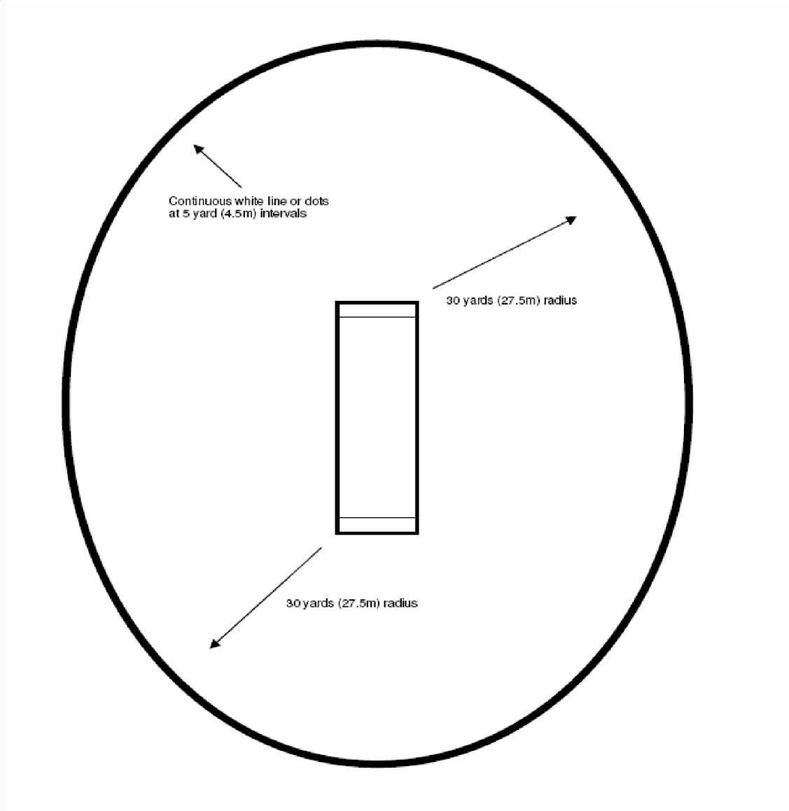

### Appendix 2

#### The Protected Area Markings

Protected Area markings must be the same width as the crease markings.

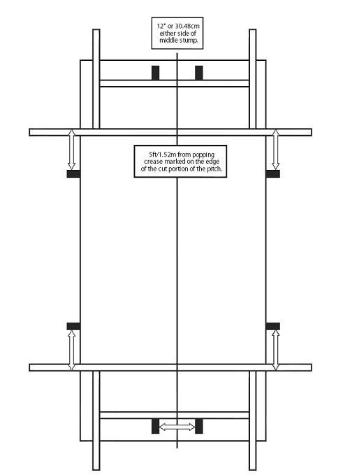

### Appendix 3

#### Wide Markings

Wide markings must be the same width as the crease markings and extend backwards from the popping crease to the bowling crease. The distance of 17 inches (43.18cm) shall be measured from the inside edge of the wide marking to the inside edge of the return crease.

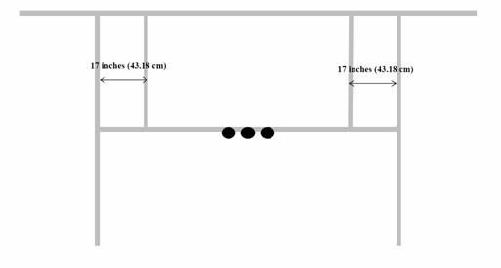

### Appendix 4

#### Maximum Overs for Under Age Medium and Pace Bowlers

**(a) Definitions**

1. Bowling Type: Bowlers of medium pace or faster (as determined by the umpires and broadly defined as one to whom the wicketkeeper would normally stand back, or one who is not considered a slow bowler). The umpires shall immediately notify the captains of both teams of each bowler who they determine should be treated differently to this broad definition.

1. Players Age: The player’s age shall be determined as their age on 31 August preceding each cricket season ( Under-19 players will be 17 or 18 on 31 August; Under-17 players will be 15 or 16 on 31 August etc.) and the appropriate bowling limitations shall apply for the entire season.

1. **Notification**

The team captain must indicate to the umpires on the team sheet each player to whom this playing condition applies and indicate their age.

1. **Bowling Limitations for Medium or Faster Bowlers**

1. **Under-19**: A maximum spell of eight (8) consecutive overs. A maximum daily allocation of twenty (20) overs.

1. **Under-17**: A maximum spell of six (6) consecutive overs. A maximum daily allocation of sixteen (16) overs.

1. **Under-15**: A maximum spell of five (5) consecutive overs. A maximum daily allocation of ten (10) overs.

1. **Under-14**: A maximum spell of four (4) consecutive overs. A maximum daily allocation of eight (8) overs.

**(d) Length of Break**

1. The break between spells is to be a minimum of 30 minutes (including the lunch interval and any unscheduled breaks in play).

1. A medium pace (or faster) bowler who has bowled a spell of less than the maximum spell permitted for their age may resume bowling prior to the completion of the necessary break, but this will be considered an extension of the same spell and the maximum spell limit for that age of player shall still apply. Following the completion of the extended spell, the normal break of 30 minutes between spells will apply and the break within the spell is disregarded.

1. If any interval or interruption in play results in an over not being completed, then that part of the over bowled after the break shall constitute one over for the purposes of calculating the medium pace (or faster) bowler’s spell and daily limits.

**(e) Change of Bowling Type**

Where a bowler changes from medium pace (or faster) to slow bowling or vice versa during a day’s play:

1. If the bowler begins with medium pace (or faster), the bowler is subject to the playing condition throughout the day.

1. If the bowler begins with slow bowling and changes to medium pace (or faster), the playing condition applies from the time of the change (first ball), and all complete overs of slow bowling bowled prior to the change shall not be taken into account in either the current spell or the daily limit.

**(f) Management**

1. It is the responsibility of the fielding captain to ensure that this playing condition is upheld.

1. If the umpires become aware of breaches of this playing condition, when the ball is dead, they shall direct the captain to take the bowler off forthwith. If applicable, the over shall be completed by another bowler who shall have neither bowled the previous over nor be allowed to bowl the next over.

1. Should a dispute or uncertainty regarding the application of this playing condition occur during play, the umpires shall make the final decision on its application based on information available from the scorers or other sources.

### Appendix 5

**Calculation sheet for use when delays or interruptions occur for team batting first in a 50 Over One-Day match**

|  |  |  |  |  |  |  |
| --- | --- | --- | --- | --- | --- | --- |
| Time innings commenced | | | |  |  | _________________ (A) |
| Net playing time available at start of the “MATCH” (4.2 minutes per over)    Excluding extra playing time if available **(see clause 3.4)** | | | |  |  | _________________ (B) |
| Length of interruption/s | | | |  |  | __________________(C) |
| Extra playing time available **(see clause 3.4 – note difference between Sat & Sun)** | | | |  |  | __________________(D) |
| Total playing time lost **( C - D )** | | | |  |  | __________________ (E) |
| Recalculated Net playing time available **( B - E )** | | | |  |  | __________________ (F) |
| Recalculated total overs of match **( F / 4.2 )** ignore fractions and add 1 if necessary | | | |  |  | __________________ (G) |
| **Match** = **15** overs per team minimum. Final = **20** overs per team minimum | | |  |  |  |  |
| **Recalculated total overs per team ( G / 2 )** |  |  |  |  |  | __________________ (H) |
| Recalculated length of innings per team **( F / 2 )** round fraction up |  |  |  |  |  | __________________(J) |
| Rescheduled 1st session cessation time **( A + C + J )** |  |  |  |  |  | __________________ (K) |
| **Length of interval (see clause 3.4)** |  |  |  |  |  | __________________ (L) |
| Time 2nd innings to commence |  |  |  |  |  | __________________ (M) |
| Rescheduled 2nd innings cessation time **( M + J )** |  |  |  |  |  | __________________ (N) |
| Maximum overs per bowler **( H / 5 )** ignore fraction  **Note:** Add **1** over maximum per bowler to equal **(H)** if necessary |  |  |  |  |  | _________________ overs |
| Revised 1st block of powerplay overs (**see clause 6.**7) |  |  |  |  |  | _________________ overs |
| 2 fieldsmen shall be permitted outside the fielding restriction area at the instant of delivery | | | | |
| Revised 2nd block of powerplay overs (**see clause 6.**7)  3 fieldsmen shall be permitted outside the fielding restriction area at the instant of delivery | | | | |  | _________________ overs |
| Revised 3rd block of powerplay overs (**see clause 6.**7)  3 fieldsmen shall be permitted outside the fielding restriction area at the instant of delivery | | | | |  | _________________ overs |

Non powerplay overs ( **see clause 6.4** ) - 5 fieldsmen shall be permitted outside this fielding restriction area at the instant of delivery **Note**: At the instant of delivery, there may not be more than **5** fieldsmen on the leg side

### Appendix 6

**Calculation sheet for use when delays or interruptions occur for team batting second in a 50 Over One-Day match**

Time innings commenced ________________ **(A)**

Net playing time available at start of the “INNINGS” (4.2 minutes per over) ________________ **(B)**

Maximum overs available at start of innings  ________________ **(C)**

Scheduled cessation time of innings ________________ **(D)**

**Including** lunch interval if applicable (**see clause 3.2**)

Length of interruption/s ________________ **(E)**

**Excluding** lunch interval if applicable (**see clause 3.2**)

**Lunch interval remains at 40 minutes if innings commenced at least 30 minutes prior to the scheduled interval**

Extra playing time available **(see clause 3.4 – note difference between Sat & Sun)** _________________ **(F)** Equivalent time innings commenced prior to scheduled lunch interval (**see clause 5.2.3**)

Total playing time lost **( E - F )** _________________ **(G)**

Recalculated total playing time (minutes) available **( B - G )** _________________ **(H)**

**Recalculated overs of innings ( H / 4.2 ) ignore fractions** __________________ **(J)**  **Match** = **15** overs per team minimum & Final **20** overs per team minimum

Rescheduled 2nd innings cessation time **( A + B + F )** _________________ **(K)**

**INCLUDE LUNCH INTERVAL IF APPLICABLE (see clause 3.2)**

Maximum overs per bowler **( J / 5 )** ignore fraction _______________ overs

**Note:** Add **1** over maximum per bowler to equal **(J)** if necessary

**See Appendix 8** (Calculation of Target Scores) **when recalculating number of overs in 2nd innings**

Revised 1st block of powerplay overs (**see clause 6.**7) _______________ overs

1. fieldsmen shall be permitted outside the fielding restriction area at the instant of delivery

Revised 2nd block of powerplay overs (**see clause 6.**7) _______________ overs

1. fieldsmen shall be permitted outside the fielding restriction area at the instant of delivery

Revised 3rd block of powerplay overs (**see clause 6.**7) _______________ overs

3 fieldsmen shall be permitted outside the fielding restriction area at the instant of delivery **Note**: At the instant of delivery, there may not be more than **5** fieldsmen on the leg side